This instruction is used to set the game library path for internal storage or an additional SD card.

Internal Storage Instructions:
A default ROMs directory has been generated for you. The path is: MagicX One35 / game
Please ensure you are inside the "game" directory and select "USE THIS FOLDER".

External SD Card Game Library Instructions:
- Please ensure your external SD card is inserted. Open the "Files" app to check if the card requires formatting. If formatting is not required, it will appear as shown in the image below:
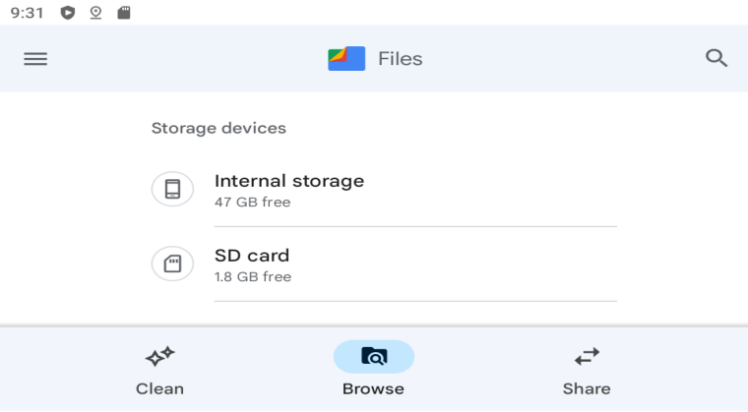
If your SD card is not recognized, you will need to enter the SD card formatting process.

- To format the SD card, swipe down to activate the Android notification bar, then swipe up until all sub-menus are displayed. Locate the SD card option, expand it, and you will see the screen shown below:
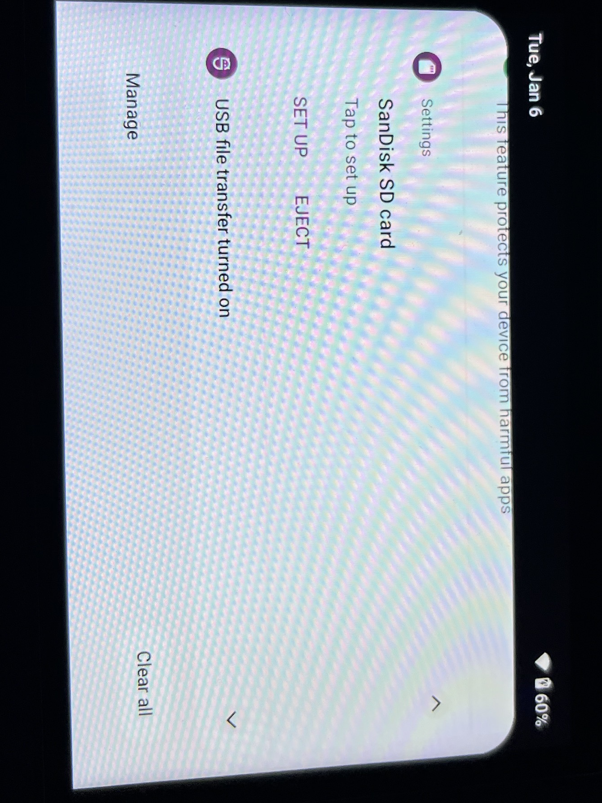
Tap SET UP to enter the SD card settings screen. Please ensure you select "Use for portable storage", and then wait for the formatting to complete

- Create a ROMs directory on the external SD card:
In Dawn, navigate to Settings, choose "Select game library directory", and tap ADD. Tap the menu icon (three lines) in the top-left corner to switch to your SD card. You need to create a folder for your ROMs in the SD card's root directory (this is required due to Android 12 restrictions). Tap the "Folder +" icon at the top to create a directory (e.g., "GAMES"). Once created, you will automatically enter that folder; select:
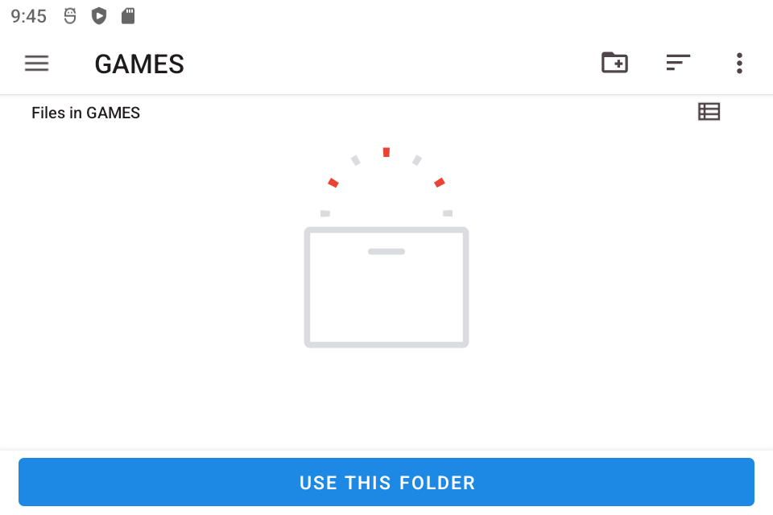

After this, you can transfer your ROMs to your SD card, and they will appear in Dawn.
Please Note: If you are transferring a large number of files, I recommend ejecting the SD card from the device and using a card reader on a PC for the transfer. This is the most efficient method.

